**APPENDIX A**

# SNAPSHOTS

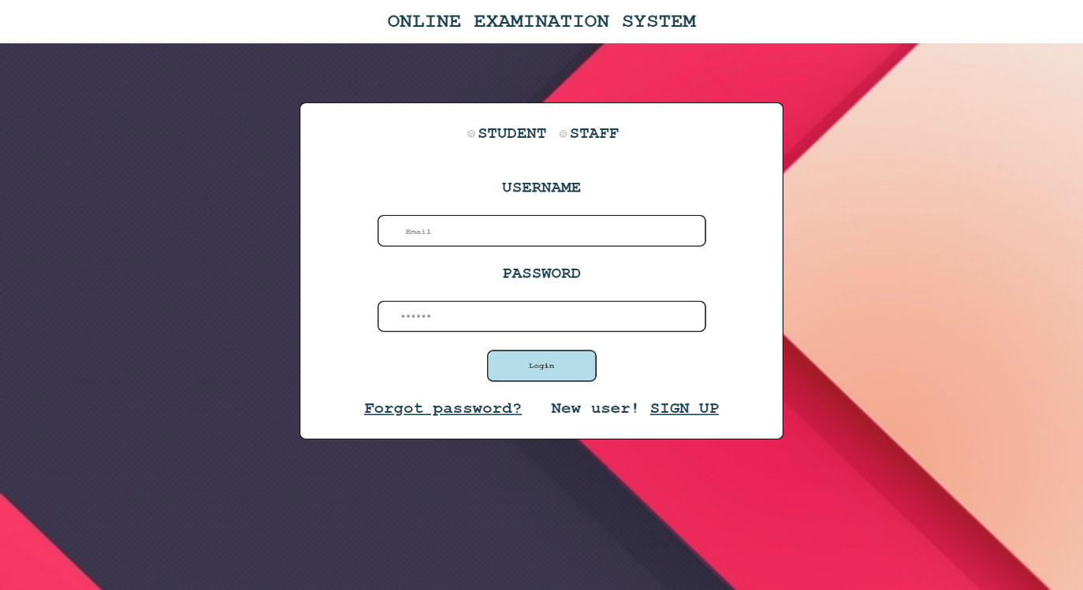

**Snapshot 1: Start page of the project**

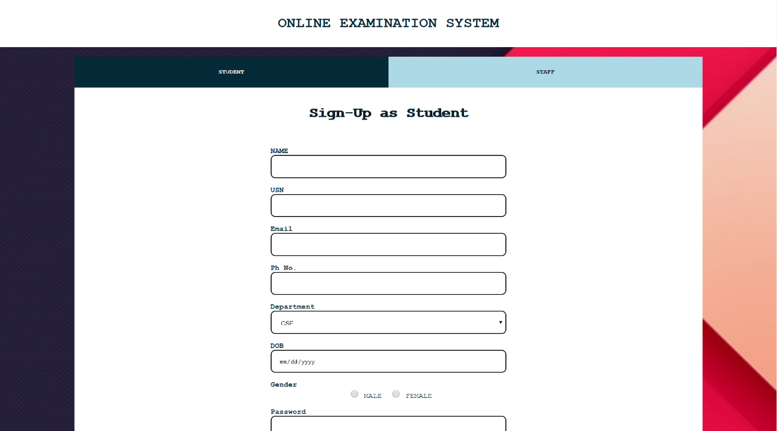

**Snapshot 2: Sign Up Page**

**Dept., of CS&E, SVIT 2019-20 15**

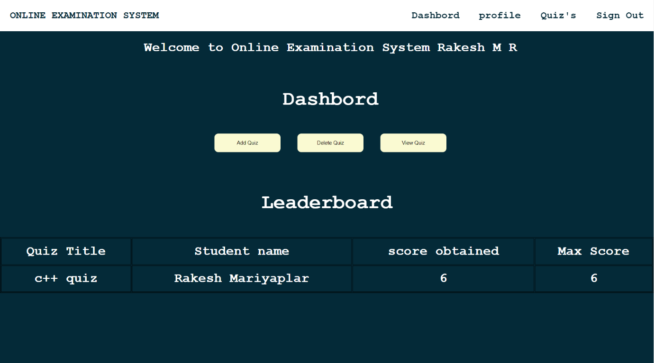

**Snapshot 2: Dashboard for Staff**

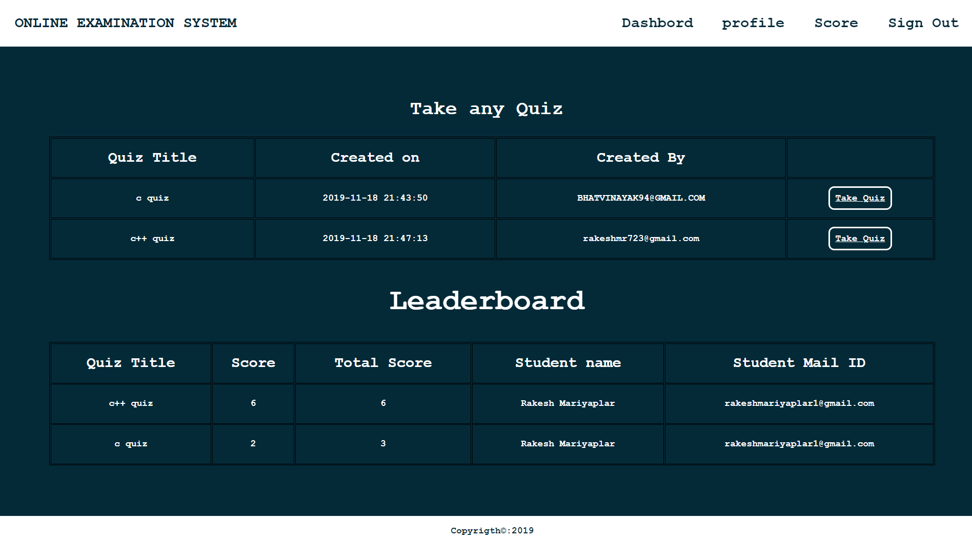

**Snapshot 3: Dashboard for Students**

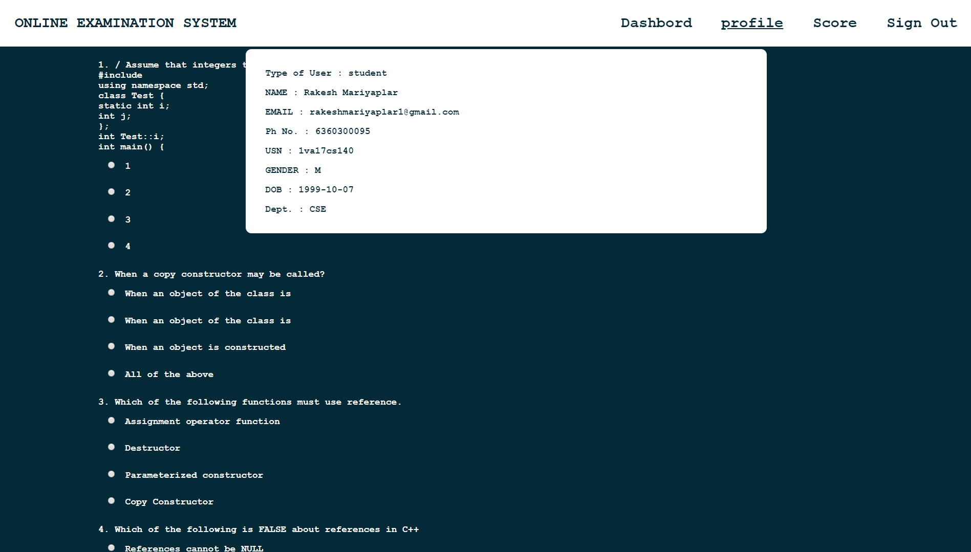

**Snapshot 4: Profile view of Student**

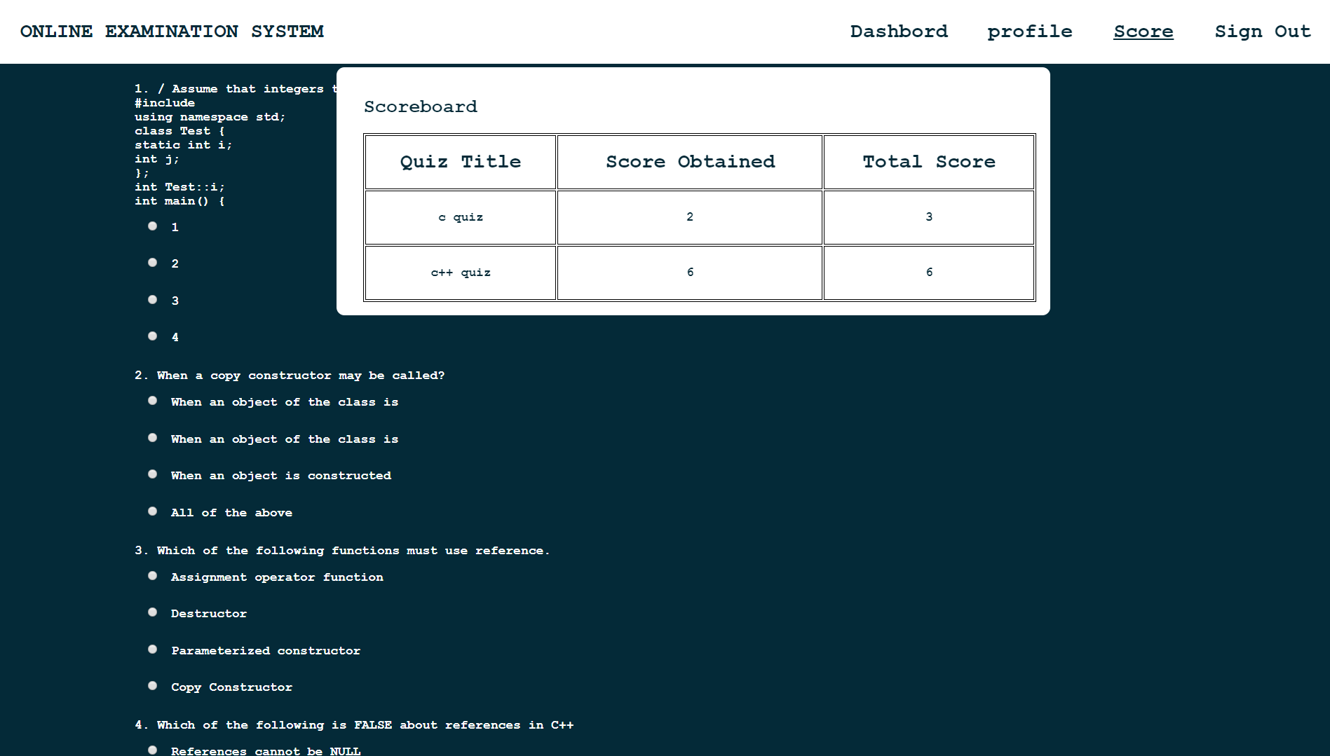

**Snapshot 5: Scoreboard of user**

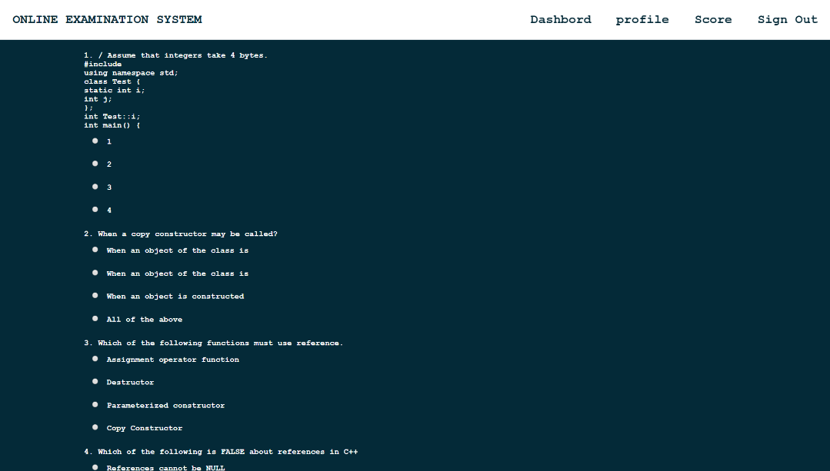

**Snapshot 6: Taking Quiz by Student**

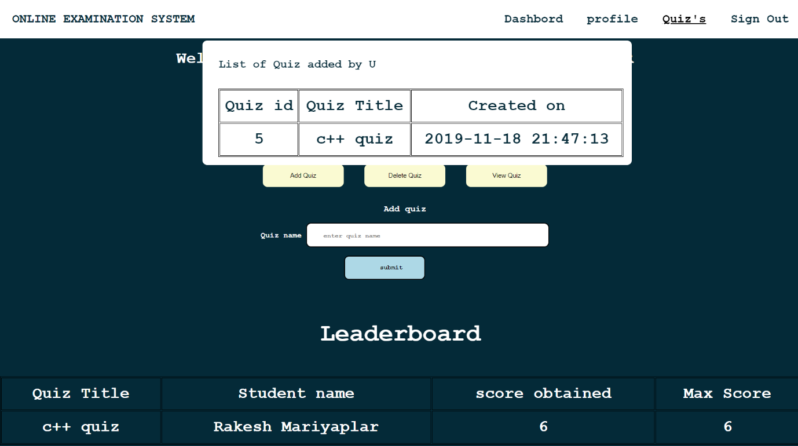

**Snapshot 7: Quiz Added by The Staff**

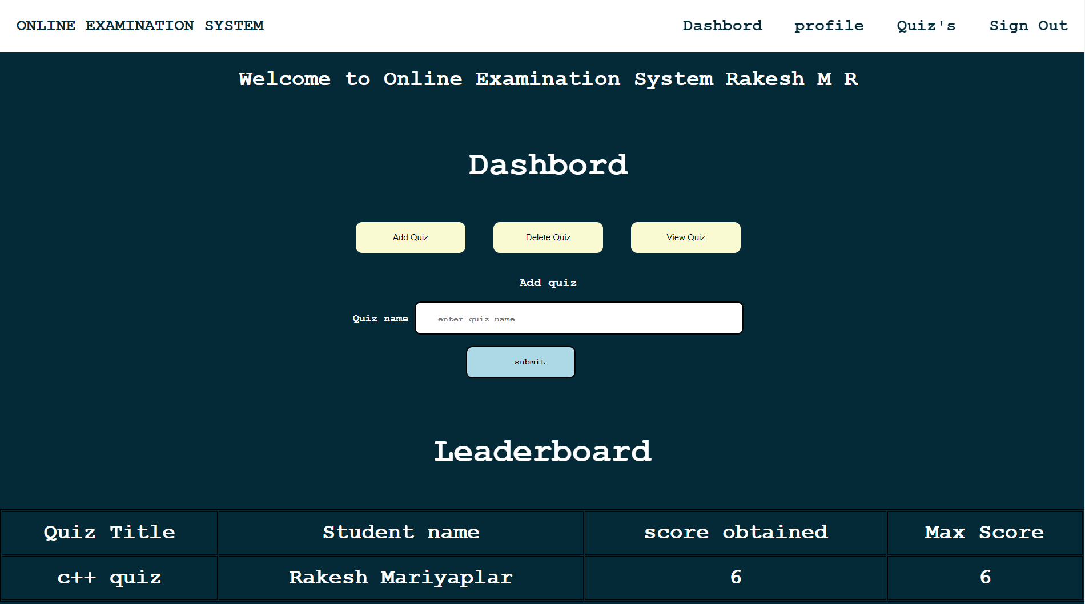

**Snapshot 8: Adding quiz page by staff**

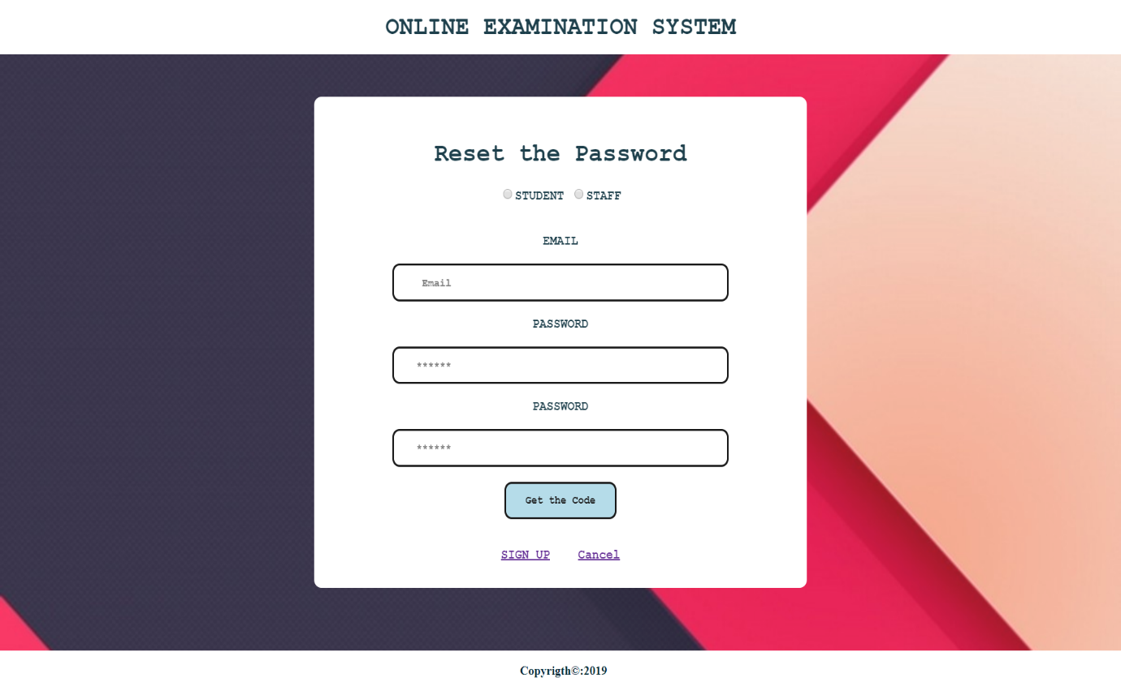

**Snapshot 9: Request for security code**

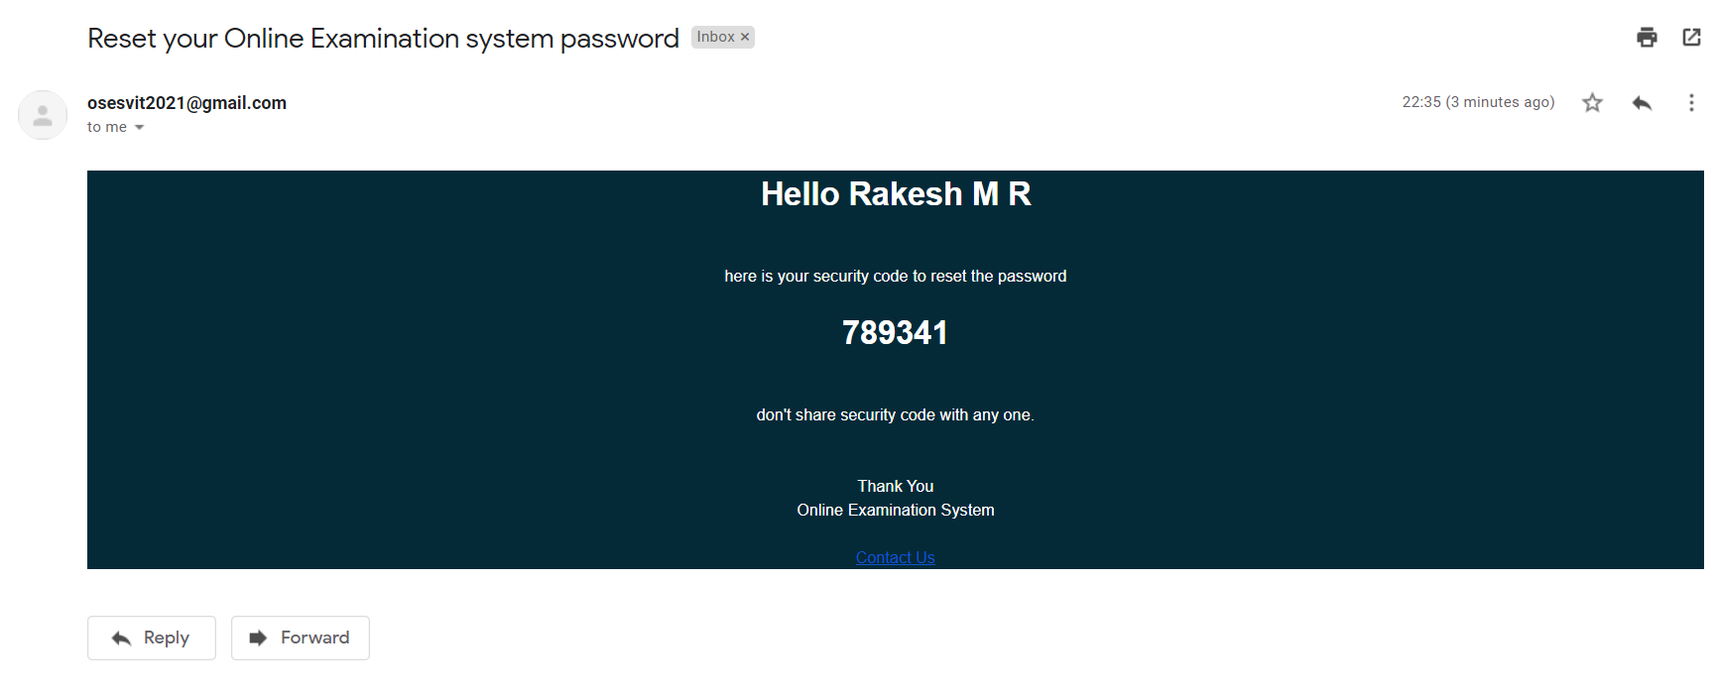

**Snapshot 10: mail received by user with security code**

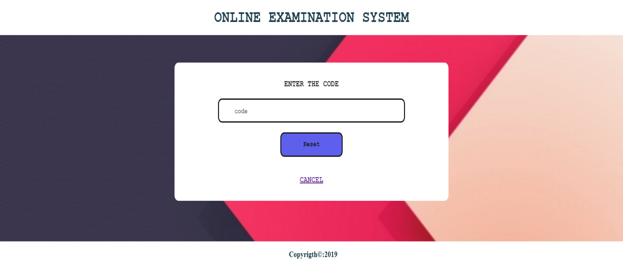

**Snapshot 11: verifying the security code and update password**